**Elementary Particles and Forces**

**Elementary Particles** 1

**Forces** 2

**Standard model of particle physics** 3

**Properties of fundamental particles** 4

**Non-Fundamental (composite) particles** 5

**Quantum Mechanics and Particle Physics** 5

**Further reading** 7

## **Elementary Particles**

One of the questions that we, as human beings, have been asking since we started thinking, is “What is the universe made up of and what holds it together?" A long time ago, Democritus tried to answer the first part by defining “atoms” – although his definition of the atom was quite different from what we know about the atom today. In the last couple of centuries, we have come a long way in terms of answering the questions about the composition of matter and the glue that holds it together – giving us the form of the universe we see today.

The quest to answer the question “What is matter made of?” has been much like unraveling Russian nesting dolls. Everything, such as a chair, table, you, and me are made up of different kinds of molecules. Every molecule is made up of different kinds of atoms. All atoms, it turns out, even if they are different, have very similar structures – they all have one nucleus around which electrons revolve. The nucleus is made up of protons and neutrons. Protons are positively charged and electrons are negatively charged particles. The number of protons and electrons in a neutral atom are exactly equal so that the positive and negative charges cancel each other out. All atoms are very similar in that they are all made up of protons, neutrons and electrons. However, a gold atom would be different from an iron atom or a hydrogen atom because they would have a different number of protons, neutrons and electrons.

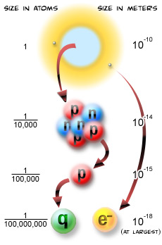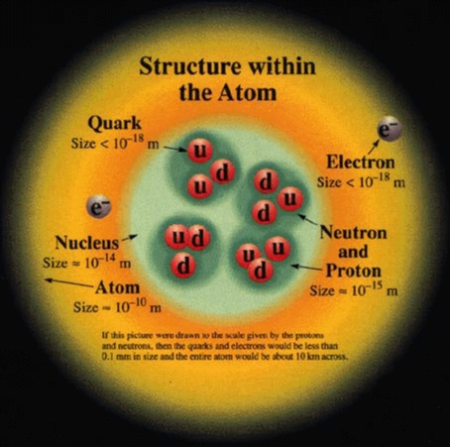

Figure 1: Scale of fundamental particles

However the atom is not the last of our Russian dolls. We know now that every proton and neutron itself is made up of even smaller particles, called *quarks*. Electrons, on the other hand, appear to be *fundamental particles*, that is, they cannot be further decomposed.

So, as of now, we can divide fundamental particles into two categories - *Quarks* and *Leptons*. There are 6 types of quarks and 6 types of leptons. Quite symmetric, don’t you think? But the symmetry doesn’t end here. They seem to form 3 pairs (we call them *families* or *generations*) as you can see from Fig.2.

Three generations of quarks (and leptons) are very similar in that they have same charge, spin etc. They differ in some internal quantum properties, but the most apparent difference is in mass – which increases as we go from 1st generation to 3rd. As you can see from Table. 2 below, this difference is up to 5 orders of magnitude.

For every particle, there is also a corresponding anti particle. Usually they have simple names, such as an anti-up quark or anti-neutrino. The anti-particle for the electron, however, has the special name “positron”. The existence of anti-matter was predicted when Paul Dirac unified quantum mechanics and Einstein’s theory of special relativity. The anti-electron was discovered a few years later by Anderson.

## http://abyss.uoregon.edu/~js/images/elem_particles.gif**Forces**

There are few other fundamental particles which don’t make up matter directly, but instead are exchanged in interactions between matter particles. These *force carrier* particles, when exchanged between two matter particles, make these particles interact through the force which they are carriers of.

There are four known fundamental forces through which particles can interact and each has its own carrier particles.

Figure 2: Three generations of fundamental matter particles

1. *Strong nuclear force*

Only quarks can feel this force through the exchange of force carrier particles called *gluons*. This force is much stronger compared to electromagnetic force of repulsion between the same charge protons and keeps the atomic nucleus stable.

1. *Weak nuclear force*

This is the force responsible for radioactive decay of atomic nuclei. It has three force carrier particles *W+, W-,* and *Z* boson. It allows one type of quark to turn into another, usually within the same generation. So a top quark can turn into a bottom quark by emitting a W boson. It also allows charged leptons to change into a neutrino. So a muon can decay to a muon neutrino by emitting a W boson. The weak force is also very important in the fusion reactions that power the sun.

1. *Electromagnetic force*

The force between charged particles is mediated through the exchange of electromagnetic force carrier particles called *photons*. This is the same photon that makes up the light you see from sun or a bulb. This is the force of attraction (repulsion) between opposite (same) electric charges or magnetic poles.

1. *Gravitational force*

The everyday force that keeps us safely on the surface of the earth and is felt by all particles with mass. Graviton, the theorized particle proposed to be the force carrier for gravity has not been discovered yet.

The forces and corresponding carrier particles are listed in Table.1.

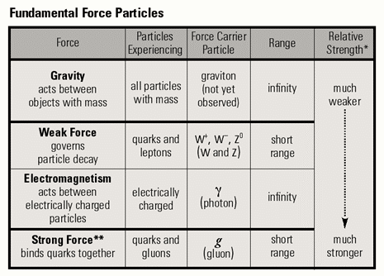Table 1: Fundamental forces and corresponding force carrier particles.

## **Standard model of particle physics**

Going back to the question “what is the universe made up of and what holds it together?” our current understanding is that the matter in our visible universe is made up of quarks and leptons which interact with one another through force carrier particles. There is a theory called the standard model of particle physics which describes this visible universe and, partly, the forces that hold it together. This theory, in principle, can describe all the physical process in chemistry and biology in terms of fundamental interactions The standard model of particle physics describes phenomenon concerning three out of the four known fundamental forces – electromagnetic force, weak force and strong force. The formal name for the mathematical structure of this theory is “gauge-invariant quantum field theory”. Gauge-invariant means that the properties of the bosons (force mediators) are determined by symmetries relating the matter fields (quarks and leptons).

The fundamental particles and some of their basic properties are listed in Table. 2.

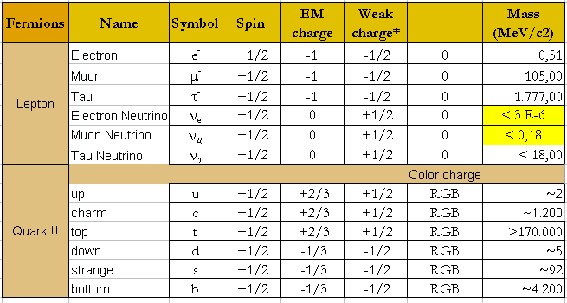

Table 2: Fundamental particles and their properties.

## **Properties of fundamental particles**

Every fundamental particle, for example a *u* quark, has exactly the same properties no matter where or how it is produced. The quarks and leptons have similar properties like charge, mass, spin etc., but quarks have one extra property called *color*. Just like particles with electromagnetic charge can only interact through the electromagnetic force, only the particles with *color charge* can interact through the strong force. This *color* has nothing to do with the color of things we see, but is a quantum (or internal) property of these particles. Every quark comes in three *colors – red, blue* and *green*. This is a useful analogy because the particles we observe directly don’t seem to have this property. In other words, they are *colorless*. According to the quark theory, just like combining these three colors gives white, combining three quarks with these three quantum properties gives a particle which does not have any *color*. So every particle that we can directly observe should be made up of a combination of either three quarks or a quark and an anti-quark, giving us the *color-less* particles we observe.

The charge of electrons and protons is equal but opposite. We say electrons and protons have 1 unit of charge (*-1e* for an electron and *+1e* for a proton, where *e* is the charge of an electron). When quark theory was formulated, the charge of a proton equaling *+1e* had to be accounted for. In order to make sure that proton’s charge comes out to be equal to *+1e*, the constituent quarks were given fractional charges, as shown in Table. 2.

The everyday matter (atoms) is made up of protons, neutrons and electrons. The proton is made of two *u* quarks and one *d* quark (does the sum of their charges work?), Thus, in terms of fundamental particles, everyday matter is made up of *u* and *d* quarks and the *electron*. These particles belong to the first family of quarks and leptons. One of the big questions physicists are trying to answer is “Why do we need three families of particles?” The standard model also does not describe phenomenon concerning force of gravity. The recent cosmological discoveries of dark matter and dark energy are also open questions not addressed by this theory.

**Let’s count:**

***Fermions*:** There are 6 leptons - electron, muon, tau and the corresponding three neutrinos.

There are 6 quarks - up, down, charm, strange, top and bottom. Every quark comes in 3 colors.

**Leptons and quarks are both *fermion*s, as they all have half integer spin 1/2.**

Now multiply the total number of particles by 2 – all these particles have their anti-particles. For every quark, there is an anti-quark, and for every lepton there is an anti-lepton. These anti-particles are almost identical to their corresponding particles except for a very few properties. For example, an *electron’s* anti-particle has the same mass but a positive charge (called *positron*).

***Bosons*:** There are force carriers corresponding to four forces – photon, *W+,W*-, *Z* and *gluons*. **These are all *bosons* with integer spin 1.**

By 1995, all of the particles predicted by the standard model were discovered except one – the Higgs boson with spin 0. In 2012, a new boson was discovered at the Large Hadron Collider. The studies done so far seem to indicate that this newly observed particle is very similar to the Higgs boson predicted by the standard model.

## **Non-Fundamental (composite) particles**

Apart from fundamental particles, more than 200 subatomic particles (made up of known fundamental particles) have been discovered using particle accelerators and detectors (see <http://pdg.lbl.gov> for a listing of the known particles). These composite particles are made up of quarks, and are of two types:

*Baryons***:** are made of three quarks, for example neutron and proton.

*Mesons*: are made of quark pairs for example pions.

Baryons and mesons are collectively called *Hadrons*.

## **Quantum Mechanics and Particle Physics**

One generally only attempts to learn about particle physics after studying quantum mechanics. Quantum mechanics is indeed fundamental to particle physics. However, if a student’s goal is to become involved in particle physics research, it is only strictly necessary to learn a small fraction of this fascinating subject. In this section, we will try to describe the minimum amount of quantum mechanics you need to understand particle physics. To really learn quantum mechanics, you need first to study differential equations, and many of your class mates are just not there yet.

Quantum mechanics is strongly relate to one of the fundamental constants of nature, called h or h-bar ( ) where .  has the numeric value of 1.054x10-34 Js. If you see this constant in an equation, you know quantum mechanics is involved.

Often quantum mechanical systems involve quantization of energies. The classic example is the energy states of the hydrogen atom (or any atom or molecule). The electrons can only have certain energies. If an atom absorbs energy, it can only do this if the energy is the right amount to move the electron between one of these discrete states (approximately… there are corrections to this that are important only when being very precise). Likewise when an atom that is in one of the higher energy states “de-excites”, it can only emit photons with energies

For example, photons, the fundamental “packet” of electromagnetic radiation, can only have energies that are integer multiples of the product of its angular frequency ( where f is the frequency of the photon’s oscillation and  where c is the speed of light and  is the photon’s wavelength) and. Thus  where n is an integer.

When you combine this with the energy levels of atoms, you get the characteristic absorption/emission spectra of atoms/molecules which can be used to identify them.

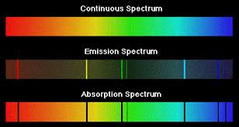

Figure : figure stolen from facultu.admiramar.edu

Another important thing to know about quantum mechanics is that it is probabilistic, in the sense often for a given initial state (say, an electron aimed at a piece of metal) there may be many possible final states (say, amount of energy that the electron loses, and the deflection of the electron from its initial direction). In quantum mechanics, you can only calculate the probabilities of the different possible outcomes; you cannot ever, even with perfect information about the initial state, predict exactly what the final state will be.

Finally, there is the Heisenberg uncertainty principal.

**Feynman Diagrams**

Feynman diagrams began as a mnemonic to help particle theorists do the very complicated calculations required by gauge-invariant quantum field theories. These calculations are done using something which is very important to practicing physicists, but rarely mentioned in undergraduate curriculum: perturbation theory. In perturbation theory, you first calculate an approximate answer (the “leading order” calculation or LO). You then calculation a correction to this answer (the “next to leading order” calculation or NLO). You then calculate a correction to this correction (NNLO). The Feynman diagrams represent aids to help in each order of the calculation. However, they are also useful for just helping to visualize how bosons are exchanged between quarks/leptons to create interactions.

The figure below shows the “LO” diagram for annihilation of an up quark and an anti-up quark to a Z boson to an electron-positron pair.

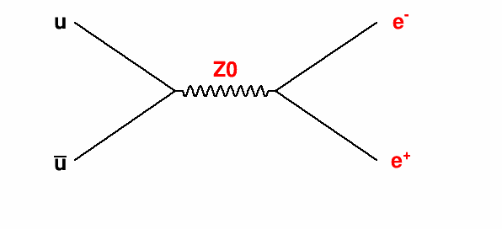

The figure below shows a NNLO (in the strong force) diagram for the same process.

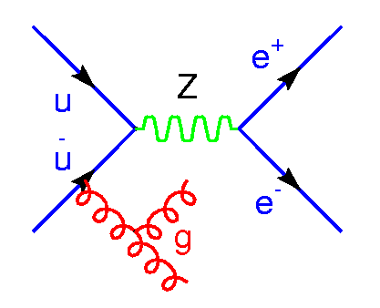

**More on Mesons**

Mesons are bound states of 2 quarks. These are very important for particle physics because, although the proton is the lightest stable particle, mesons are the lightest states containing quarks. They are “unstable”, meaning that they decay, sometimes very quickly, to other types of particles.

The lightest mesons are called pions. There are three of them, one with a positive charge, one neutral, and one with a negative charge. The charged pions decay via the weak force to a muon and a neutrino. The neutral pion usually decays to two photons.

The naming conventions for all the mesons are very strange because the standard model and the existence of quarks was not yet understood when they were discovered. Thus there are “kaons” that contain strange quarks, “D mesons” that contain charm quarks.

As with the hydrogen atoms, there are also excited state of the two bound quarks. While with hydrogen, we just say “excited hydrogen”, with the mesons, the excited states often have separate names, as it was not understood at the time of their discovery that they were essentially “excited pions”. Thus rho mesons, eta mesons, etc are in a sense excited states of bound states of the up and down quark.

## **Further reading**

* pdg.lbl.gov is always a great site for all things related to particle physics
* “Modern Particle Physics” by Mark Thomson
* “Introduction to Elementary Particle Physics” by Alessandro Bettini

.